Debugging the Deboo Integrator

Symptom: Drooping staircase treads. Measure to have a time constant of 0.18ms

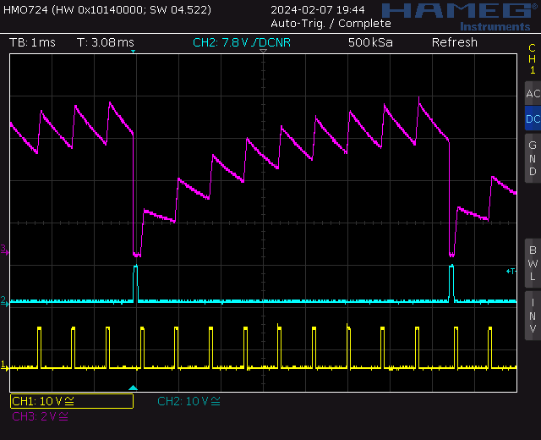

Clue: Notice that the FRAME signals is sitting at around 670mV. Measured with cursors. This partially turns on the MOSFET responsible for discharging the Deboo capacitor.

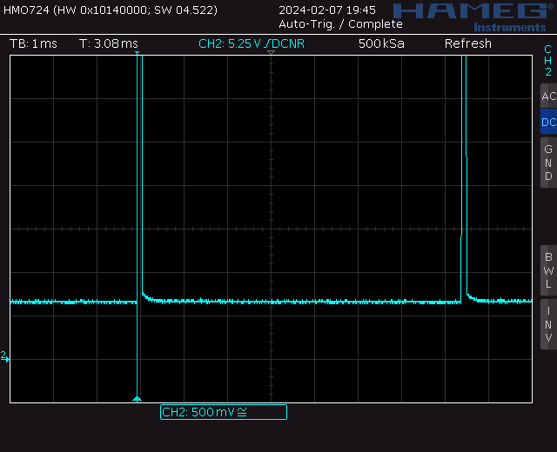

Why is the STRO output at 670mV. Well this is a diode drop above ground.

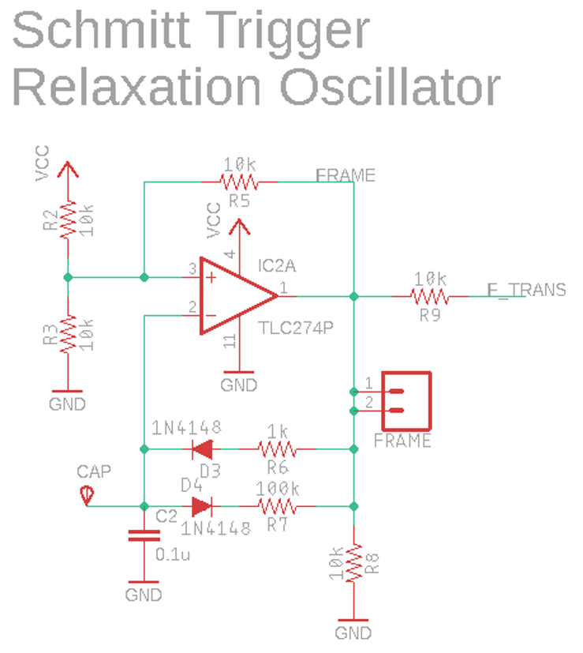

Verified TLC274 ground pin is at 0V, not 670mV.